Order form: − P&C membership brochure

P&C membership brochure
The P&C membership brochure has been designed to help you attract members to your P&C and includes a membership application form. It is A4, folded once and perforated to detach the membership form. There is space on the brochure for you to write/stamp your P&C’s contact details or, for an additional cost, we can print your details on labels that you can stick on each brochure. Brochures must be ordered in multiples of 100.

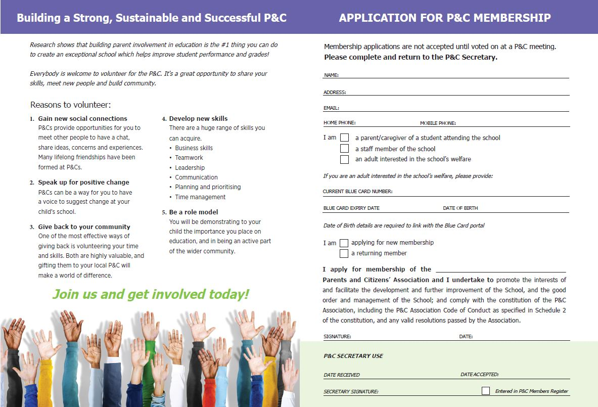

Costs
Item Quantity/Type Amount
Brochures 100 $15.00
Labels 100 $16.50

How to order
This form should be signed by the P&C President, then mailed or emailed to the P&Cs Qld State Office.
All orders will be dispatched within 14 days.
Payment must accompany this order form (see other side for payment options).

Postage and handling
Postage for up to 500 brochures/labels: $20.00.
Postage for more than 500 brochures: Please contact the P&Cs Qld State Office on 1800 218 228 or 3352 3900.

Order form: − P&C membership brochure

Contact name:
School name:
Postal address:
Phone number:
P&C President (name):
P&C President (signature):
Date:

Product | Quantity | Price |  | GST | Total

Membership brochures

Labels

Postage
 |  |  |  | Total:

Contact details to be printed on labels (if applicable)

P&C contact
(name & number)
School name:
School phone:
School website:
P&C email:

How to pay
All prices quoted exclude GST. Postage costs will apply.
Direct deposit to Westpac BSB 034 041 account number 143839
(Please send remittance advice to P&Cs Qld via email)

